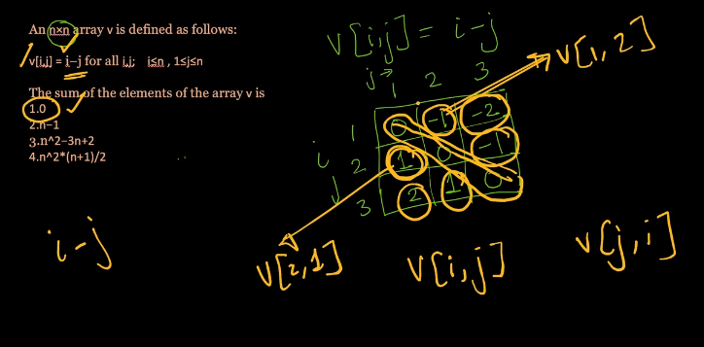

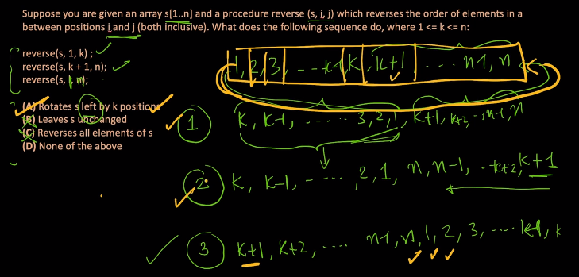

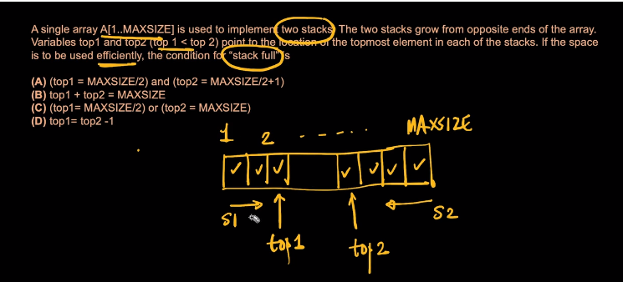

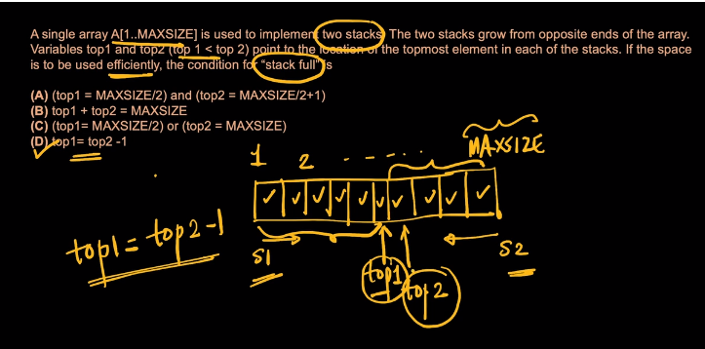

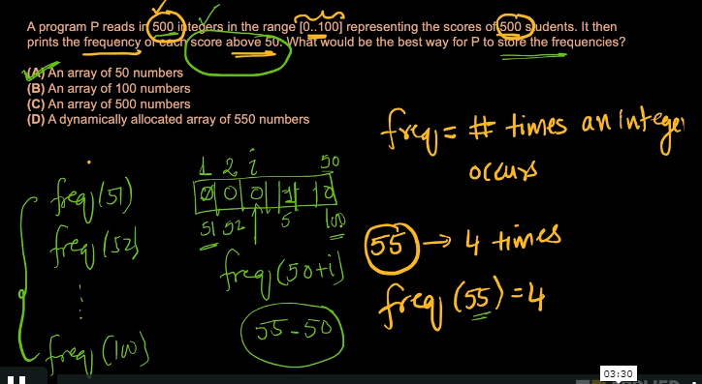

Row- and column-major order

In computing, **row-major order** and **column-major order** are methods for storing [multidimensional arrays](https://en.wikipedia.org/wiki/Multidimensional_array) in linear storage such as [random access memory](https://en.wikipedia.org/wiki/Random_access_memory).

The difference between the orders lies in which elements of an array are [contiguous in memory](https://en.wikipedia.org/w/index.php?title=Contiguous_in_memory&action=edit&redlink=1). In a row-major order, the consecutive elements of a row reside next to each other, whereas the same holds true for consecutive elements of a column in a column-major order.

